Architects In Annanagar – Saving The Environment

It is the responsibility of every human being to preserve the ecological health of the planet. Everyone wants to see change in their living space, be it home or office. The buildings have to blend in with nature instead of replacing nature. This is where architects play a pivotal role. Creating energy efficient buildings is important and green designs have to be incorporated in every building design. Recently the skyline of Annanagar is changing with people involved in cleaner and greener design concepts. Architects in Annanagar have to be concerned about the ecosystem they live in to make it healthier by controlling pollution impact on the planet.

Role of eco friendly architects
Services of green architects are most sought after by people concerned about global warming and the rising sea levels. Every year the incidents of natural disasters in the form of floods, hurricanes, tsunami, earthquake, forest fire, etc are rising. The reason behind is the lack of awareness of protecting our planet from the harms of pollution and unplanned use of natural resources. Green is no longer associated with just color but has gone a step further relating to the environment conscious lifestyle.

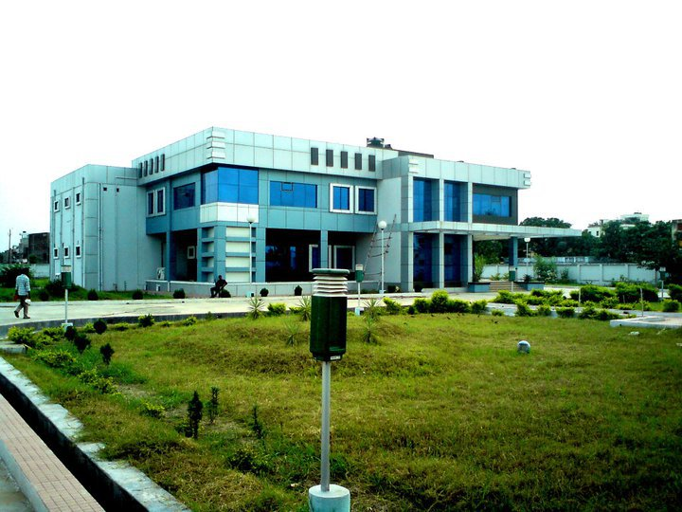
What is green architecture?
Green architecture can be termed as environment sensible construction and design concepts. It is related to energy saving, use of natural materials and sustainable development. In short it is the relationship between architecture and ecology. The major aspect of green architecture is creating harmony with the environment we live in. Green building should translate into a natural landscape and this includes the use of building materials. Green materials could be recycled or restored resources.

Benefits of green architecture
- Optimized use of energy and water. Resource recycling is practiced during construction and after the building is constructed.
- It causes very low environmental impact during the life cycle of the construction and maintenance.
- Natural topography is put to maximum use thereby optimizing energy usage
- The operating cost is drastically reduced as the resources are used to the maximum. The focus is on building material available on the building site. Adding insulated doors and windows can cut down on energy wastage.
- Green architecture improves the quality of indoor air and thereby the health of the dwellers in the building. Through natural ventilation, the occupants enjoy a healthy life.
- It reduces waste and thereby minimizing the use of landfills

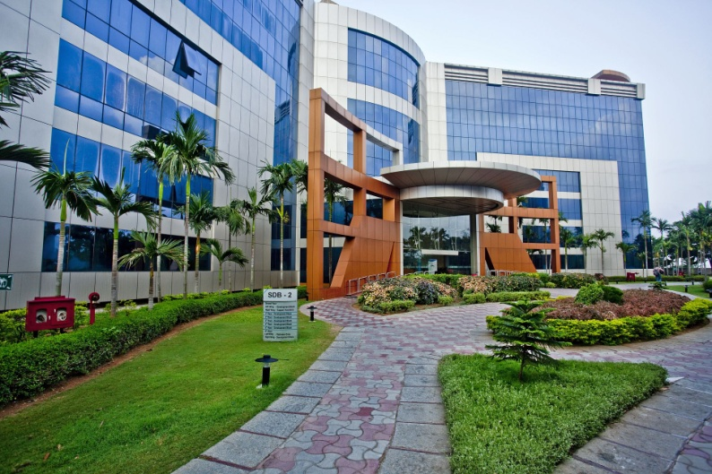

What materials are used in the process of green architecture?
Recycled wood, tiles, bricks, etc all available on the site or close to the building site can be put to maximum use. When a new material is needed, the focus should be on replenished materials like bamboo, which is easily harvested. While using insulation material it is best to use low volatile organic compounds for instance, recycled denim instead of fiberglass. Treating the insulation material with boric acid can protect from insect infestation. Use of organic milk paints is also suggested. It is both cheap and natural. Solar energy is available in abundance in tropical countries and it is only wise to make use of it. Gravel parking lots drains water slowly when compared to concrete and it helps in replenishing the ground water.

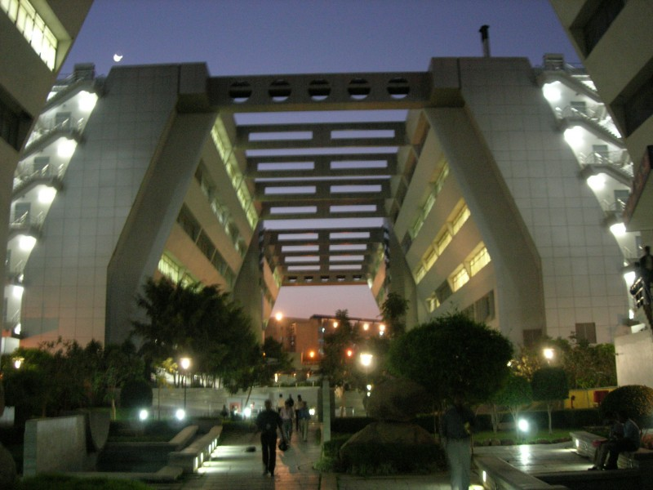

Green architecture is more a necessity than a fad. Builders and architects have to understand the value of our planet and embrace eco friendly building techniques.

Contact Us:

Srishti Design Studio

AL-183, AL First Street,
11th Main Road,
Annanagar,
Chennai- 40

+91 44 43542095

info@srishtistudio.com

