An Overview Of Hex Bolt
Hex Bolt is a type of fastener, which is mainly used to fix different things that are separated in nature and are easily combined with their help. The market is flooded with a wide array of different sizes, shapes, and other specifications and mainly used in industries like construction, manufacturing, automobile, etc. the most popular of its types available in different material like stainless steel, cast, iron, MS, aluminum, PVC, Hex etc. Hex Bolt Manufacturers offer a collection of bolts in different specifications, which are designed as per the industry guidelines.
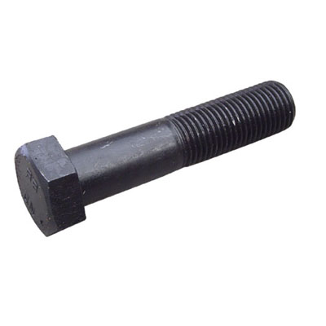
The reason behind these specifications is that the demand of every industry is different and it allows the buyer to pick the suitable option as per their need. These are because of its robust structure give 100% protection from the corrosion and keep a hold on the object for a longer time. These are very light in weight and are flexible in nature, which not only increase its application area but also its efficiency. These are safe to use in outdoor as well as indoor applications because of its high-performance and capability to withstand any environmental condition. One of the best things about bolt is that these are inexpensive in nature and help you to do multiple tasks.
In all of its types, Hex Bolt is the most popular in all over the world due to its hexagonal shape. After knowing all its benefits, you can buy any type of Bolt as per the need of your industry. You can contact Swarna Fasteners one of the prominent Hex Nut Manufacturers to buy it in different categories. So, what are you waiting for? Pick your phone and give us a call to place your order now. We are right here to answer your queries within a mean time.

